Trupti Thakur

Lab _10

Write up

1. Function 4

F(x) = x^3 - 7*x^2 + 15*x - 9

Function gets zero approximately between points (-1 to 1)

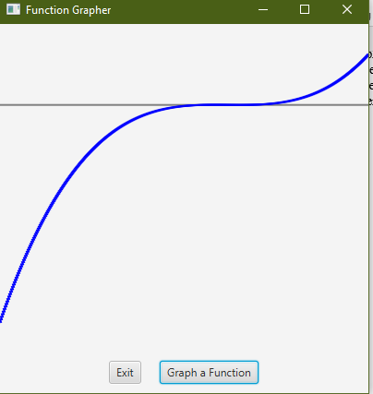

Function 5

F(x)=sin(1/x)

From the graph we can see that as x gets closer to zero number of oscillation increases.

It does not settle on one value. Hence Limit as x approaches zero from right does not exist.

